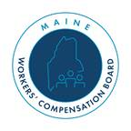
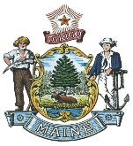
STATE OF MAINE
WORKERS' COMPENSATION BOARD
Janet Mills Governor
John Rohde
Executive Director/Chair

The Workers’ Compensation Board Caribou Regional and

Advocate Offices are moving from 43 Hatch Drive, Caribou

to 658 Main Street, Suites 1 and 2, Caribou

effective March 11—12, 2026

Please visit us at our new location:
658 MAIN STREET, CARIBOU, ME 04736

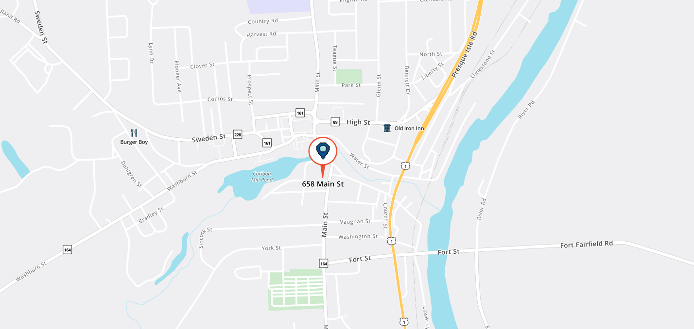

- Phone, fax & email will remain the same.
- New mailing and physical address (effective March 11th):
Regional: 658 Main Street, Suite 1
Caribou, ME 04736
Advocate: 658 Main Street, Suite 2
Caribou, ME 04736

You will not be able to reach us by telephone, fax or email while we are in the process of moving, March 11th and 12th, 2026.

Directions to New Caribou Regional Office

658 Main Street, Suite 1

Caribou, ME 04736

FROM POINTS SOUTH:
- Head north on I-95.
- Take exit 302 toward US-1 North/Presque Isle. Drive for 0.3 miles.
- Turn left onto North Street (US-1 N). Drive 26.4 miles.
- Turn left onto Benjamin Street (US-1). Drive 26.6 miles.
- Turn left onto Fort Street (ME-161). Drive for 0.3 mile.
- Turn right onto Main Street (ME-161/ME-164). Drive for 0.3 mile.
- The office is on the left, 658 Main Street.
- Park in front of the building and use the front left-hand building entrance.
- Walk down the hallway to the lobby and reception windows on the right.
FROM POINTS NORTH:
- Head south on US-1.
- Take the 1st exit from roundabout onto Main Street. Drive 1.2 miles.
- Turn right onto Herschel Street (ME-161 N). Drive 0.1 mile.
- Turn left onto Record Street. Drive 482 feet.
- Continue on Hatch Drive (ME-161/ME-164). Drive for 0.2 miles.
- The office is on the right, 658 Main Street.
- Park in front of the building and use the front left-hand building entrance.
- Walk down the hallway to the lobby and reception windows on the right.

