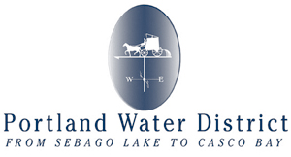

**Portland Water District Summer Job Opportunity**

***Watershed Protection Specialist***

The **Portland Water District (PWD)** is seeking job candidates for a seasonal watershed protection specialist. PWD has an environmental source protection group that works on and around Sebago Lake, which is the drinking water supply for the greater Portland area.

The summer watershed protection specialist position includes such duties as: environmental sampling, field inspection work, limited laboratory analysis, basic GIS, and working with lake scientists, security, and education/outreach staff to enhance our various lake protection programs. A primary responsibility of this position will be to organize and conduct PWD’s seasonal Sebago Lake Beach Monitoring Program.

Candidates for this position must have completed a minimum of two years of college coursework in environmental science or a related field and be comfortable and capable of interacting with the public in a respectful and professional manner. Please see the complete job description at our website.

This is a paid position at $17.00 per hour, and will begin in mid-May and continue through mid-September. The schedule can be flexible for the right candidate. The normal work schedule is Monday through Friday with the expectation to work a minimum of 24 hours up to 40 hours per week depending on the successful candidate’s availability, skill set, and experience. Limited weekend work may also be required as needed.

Please visit [**https://www.pwd.org/watershed-protection-specialist-summer-months**](https://www.pwd.org/watershed-protection-specialist-summer-months)to complete an application and to submit a resume and cover letter.