**⮚ MSMA QUARTERLY UNEMPLOYMENT – MSMA MAILS INVOICE FOR QUARTERLY AMOUNT DUE – PAY ACCORDING TO THE INVOICE, *(FILL OUT AN “AP PAY TO” AND ATTACH A COPY OF THE INVOICE FOR SUPT TO SIGN AND AP TO PROCESS – CHECK COMES BACK TO ME TO PROCESS)* ERP REPORT IS NOT CORRECT AMOUNT TO PAY (MSMA ESTIMATES ANNUAL AMOUNT AND BILLS ACCORDING TO THE ESTIMATE)**

***THE “AP PAY TO” FORM IS IN MY GOOGLE DOCS UNDER MSMA UNEMPLOYMENT - PROCEDURES - REQUEST FOR PAYMENT***

##### QUARTER 1: JANUARY 1 – MARCH 30 DUE APRIL 30

# ***QUARTER 2: APRIL 1 – JUNE 30 DUE JULY 31***

# ***QUARTER 3: JULY 1 – SEPTEMBER 30 DUE OCTOBER 31***

***QUARTER 4: OCTOBER 1 – DECEMBER 31 DUE JANUARY 31***

⮚ ERP → PAYROLL → REPORTS → COMPENSATION STATEMENTS → ME - QUARTERLY WAGE FILE → REPORT PARAMETERS ARE AUTO-FILLED EXCEPT FOR **ACCOUNT SUFFIX - TYPE IN “ME”, REPORT TYPE - CHOOSE “GROSS WAGES - SECT 125” AND FILE TYPE - CHOOSE “WAGE ONLY”** → APPLY SELECTION → OK → FILE PATH SHOULD SAVE TO DOWNLOADS (FILE IS AUTOMATICALLY NAMED “WAGEONLY” → OK → SAVE

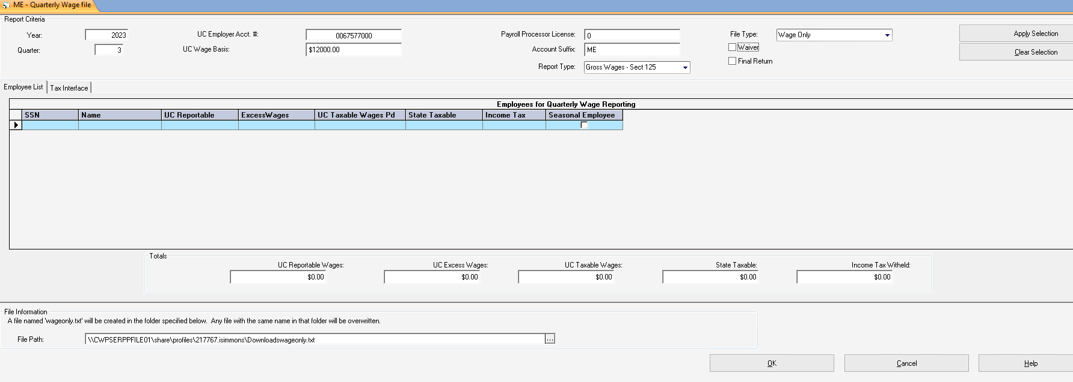

**⮚ ONCE SAVED, DOWNLOAD TO DESKTOP AS FOLLOWS:**

ERP → 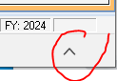SELECT “CARROT” AT BOTTOM OF SCREEN AND DOWNLOAD → SELECT FILE AND OPEN → CLOSE BOX THAT OPENS UP AFTER DOWNLOAD IS COMPLETE → OPEN FILE THAT IS CREATED ON LOWER LEFT HAND SCREEN → SAVE AGAIN ON DESKTOP / TEMPORARY DOWNLOADS / MSMA UNEMPLOYMENT - NAME THE FILE “2023 3RD QUARTER UNEMPLOYMENT”

⮚ GOOGLE CHROME → BOOKMARKS → [RE Employ ME Unemployment Services Login](https://reemployme.maine.gov/accessme/faces/login/login_local.xhtml) (SEE ATTACHED PRINT SCREENS FOR LOGIN AND UPLOADING → **MAKE A NOTE OF THE REPORT NUMBER TO INCLUDE ON THE INVOICE FROM MSMA → PRINT CONFIRMATION PAGE → MAIL INVOICE AND CHECK TO MSMA → ATTACH CONFIRMATION PAGE TO COPY OF INVOICE AND CHECK AND FILE IN CABINET

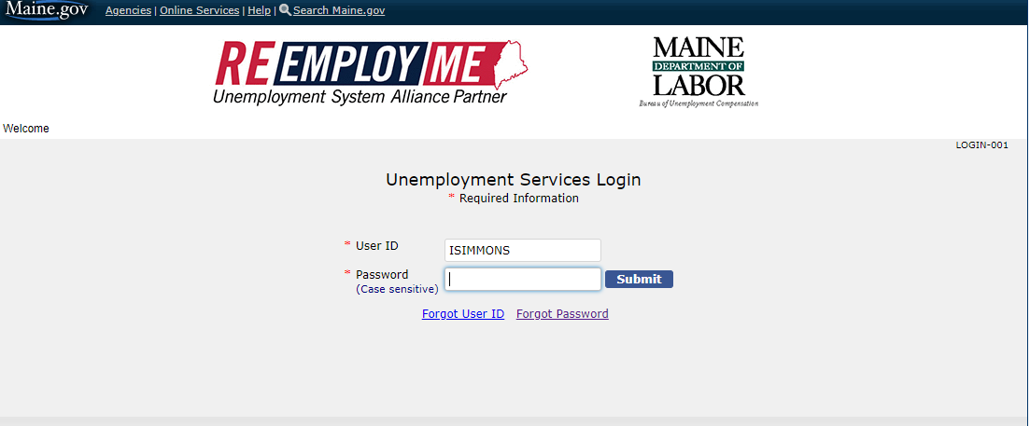

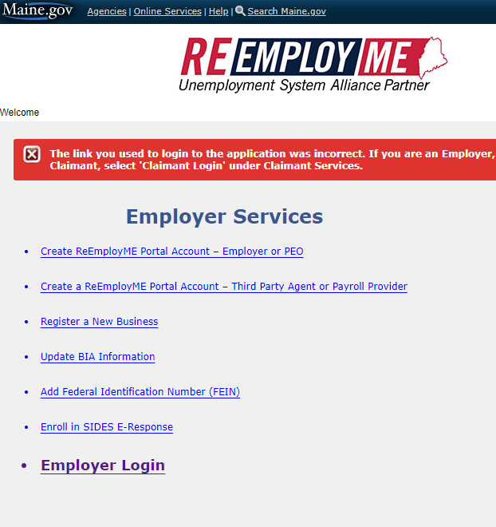

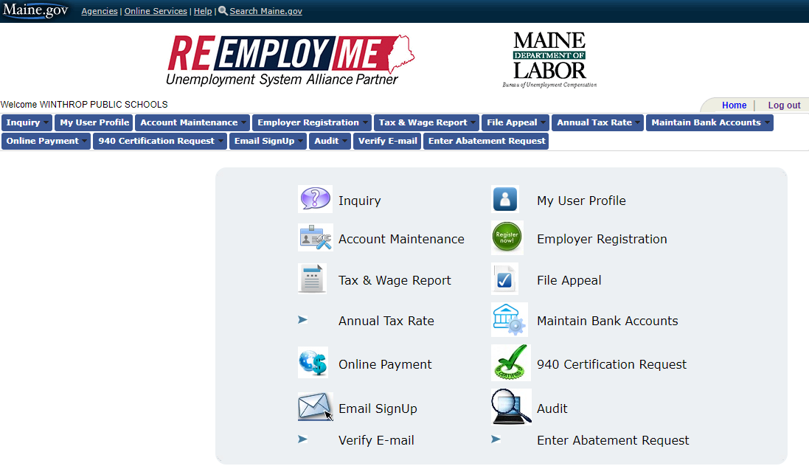

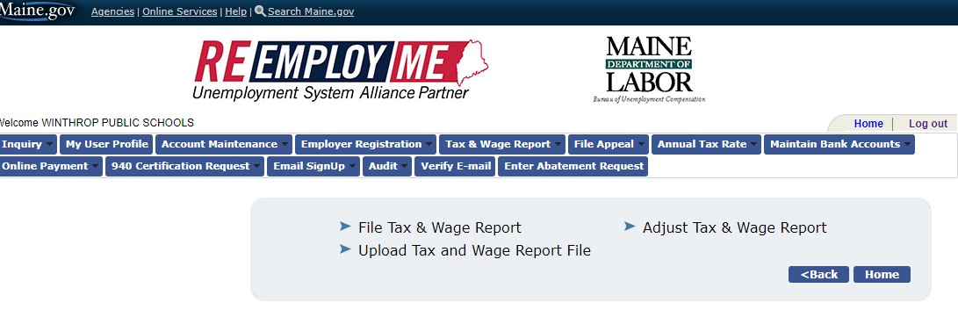

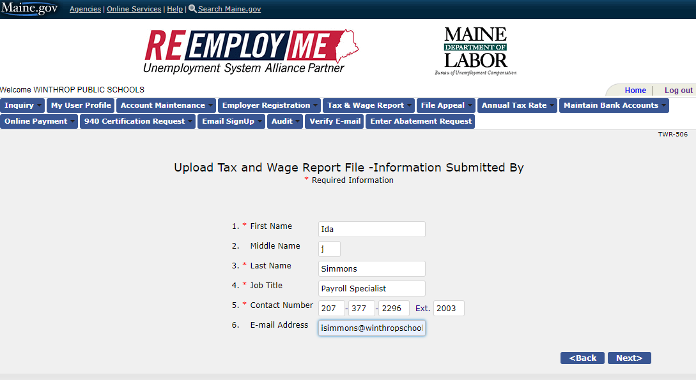

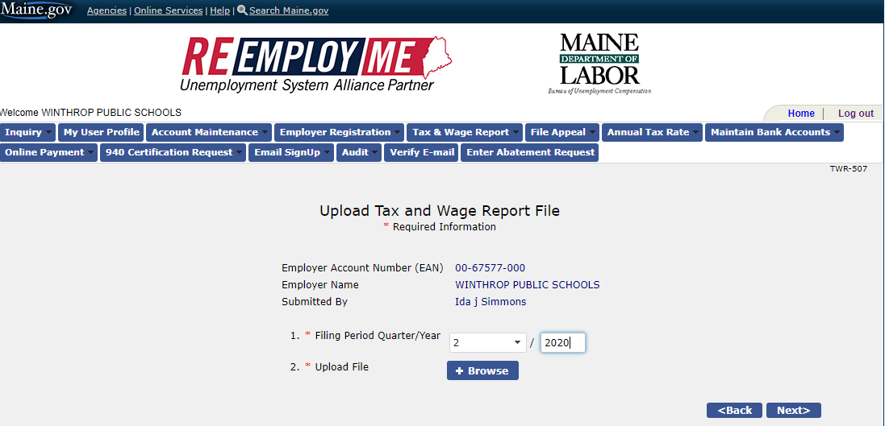

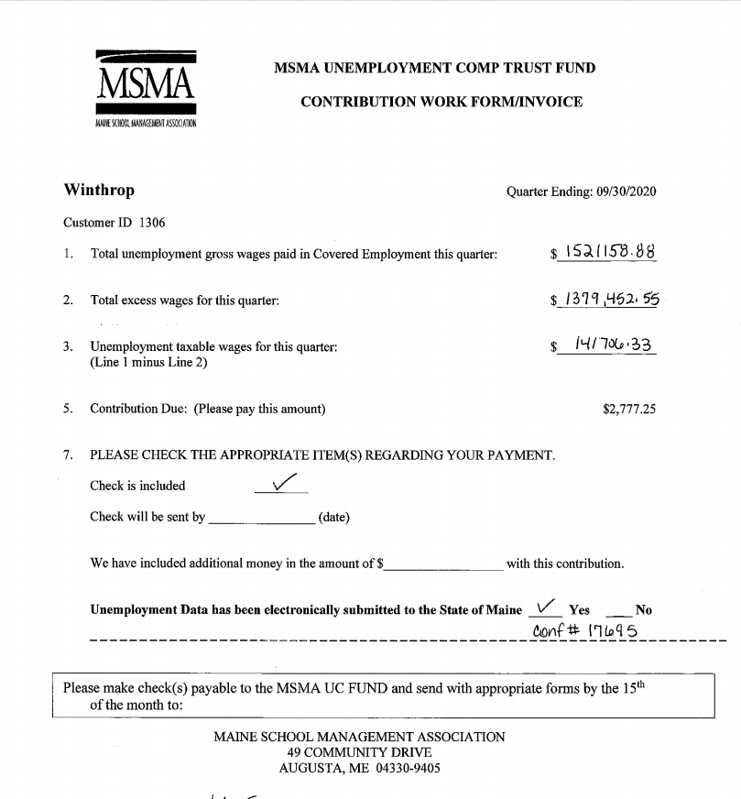

**WINTHROP PUBLIC SCHOOLS**

**17A Highland Avenue, Winthrop, ME 04364**

**Ph 377-2296 Fax 377-2708**

**REQUEST FOR PAYMENT**

|  | **Payroll** |  | **x** | **Accounts Payable** |
| --- | --- | --- | --- | --- |

**Date: __________________**

**Make Check Payable To: __MSMA Unemployment Contribution Fund_____**

**Address: __49 Community Drive________________________**

**__Augusta ME 04330_________________________**

**In the Amount of: __$ (from MSMA Invoice, Not ADS Report)_____**

**Reason: ___ Quarter (2023) Unemployment**

**Signature: _______________________________________________**

**Payroll Specialist**

**Signature: _______________________________________________**

**Superintendent**

**Notes: ____Please give check to Ida for processing__________**

**RETURN WITH PROPER SIGNATURES TO THE BUSINESS OFFICE**