**⮚ MAINE REVENUE SERVICES ELECTRONIC FILING (STATE WITHHOLDING TAXES) – MUST COMBINE WITH TOWN**

##### ***QUARTER 1: JANUARY 1 – MARCH 30 DUE APRIL 30***

# ***QUARTER 2: APRIL 1 – JUNE 30 DUE JULY 31***

# ***QUARTER 3: JULY 1 – SEPTEMBER 30 DUE OCTOBER 31***

***QUARTER 4: OCTOBER 1 – DECEMBER 31 DUE JANUARY 31***

⮚ ERP → PAYROLL → REPORTS → COMPENSATION STATEMENTS → ME - QUARTERLY WAGE FILE → REPORT PARAMETERS ARE AUTO-FILLED EXCEPT FOR FILE TYPE → CHOOSE “WITHHOLDING ONLY” FOR FILE TYPE → APPLY SELECTION → CHECK THAT INCOME TAX WITHHELD MATCHES SPREADSHEET / PAYROLL REPORTS → FILE PATH SHOULD SAVE TO DOWNLOADS (FILE IS AUTOMATICALLY NAMED “WITHHOLDINGONLY” → OK → SAVE

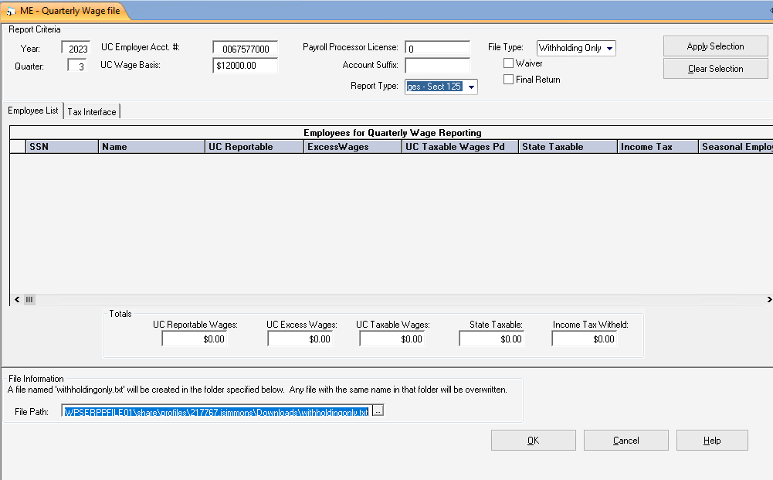

**⮚ ONCE SAVED, DOWNLOAD TO DESKTOP AS FOLLOWS:**

ERP → 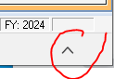SELECT “CARROT” AT BOTTOM OF SCREEN AND DOWNLOAD → SELECT FILE AND OPEN → CLOSE BOX THAT OPENS UP AFTER DOWNLOAD IS COMPLETE → OPEN FILE THAT IS CREATED ON LOWER LEFT HAND SCREEN → SAVE AGAIN ON DESKTOP / TEMPORARY DOWNLOADS / 941 AND MAINE REVENUE - NAME THE FILE “ME 2023 3RD QUARTER SCHOOL”

⮚ THE TOWN EMAILS THEIR QUARTERLY TEXT FILE (MUST BE IN NOTEPAD FORMAT) → MERGE TOWN AND SCHOOL FILE → DELETE DUPLICATE HEADER ROWS AND CHANGE THE NUMBER OF EMPLOYEES AND AMOUNT OF DEPOSITS TO REFLECT BOTH TOWN AND SCHOOL (SEE ATTACHED SAMPLE OF CORRECT UPLOAD FILE FORMAT)

⮚ GOOGLE CHROME → BOOKMARKS → MAINE REVENUE SERVICES TAX UPLOAD → USERNAME IS “ISIMMONS” / PASSWORD IS WINps@2019aa → A SECURITY CODE IS TEXTED TO MY PHONE → ENTER THE CODE → GO TO “MORE” TAB → SCROLL DOWN TO PAYMENTS & RETURNS → SELECT UPLOAD BULK WITHHOLDING FILE

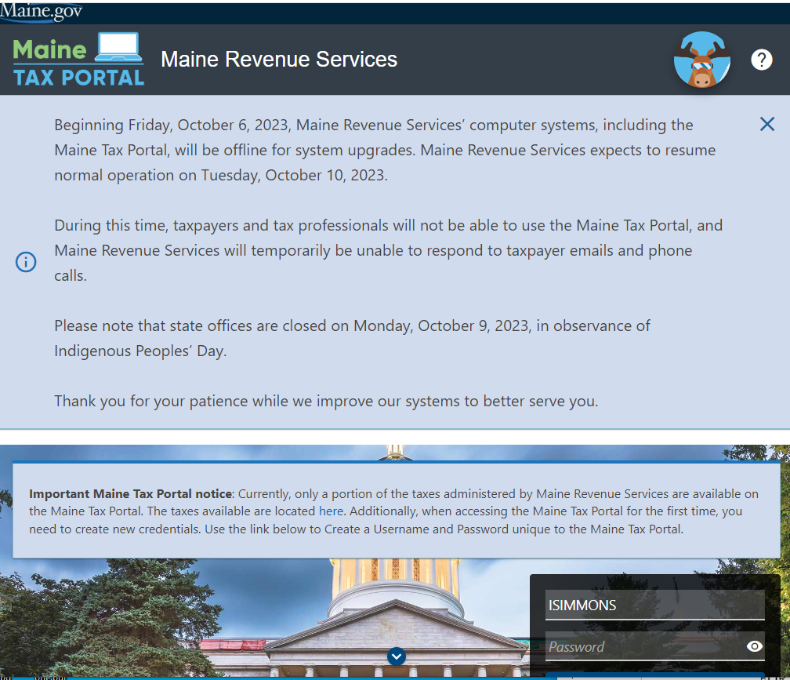

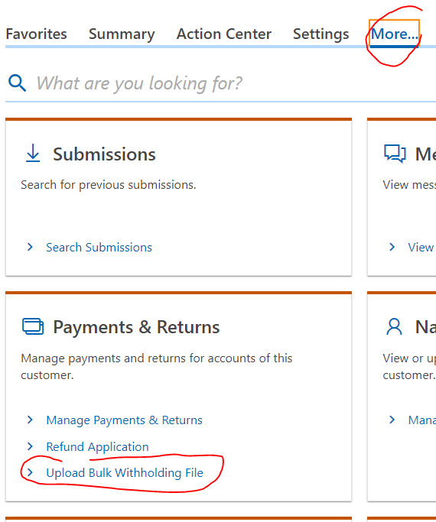

FILE TYPE = 941ME BULK WITHHOLDING → ENTER CURRENT YEAR → ENTER CURRENT QUARTER → NEXT

⮚ IF OVERPAYMENT, REFUND IS ISSUED AUTOMATICALLY

⮚ IF ADDITIONAL PAYMENT IS DUE, FILL OUT AP REQUEST FOR PAYMENT AND ATTACH ***VOUCHER (THIS FORM IS SAVED IN MY DRIVE, TAX INFORMATION, ME REV SVCS AP PAYMENT REQUEST.)***  → KEEP COPY → CHECK IS RETURNED TO ME FOR PROCESSING → MAKE COPY OF CHECK AND VOUCHER → MAIL TO MAINE REVENUE SERVICES → FILE IN CABINET