**SPPS Monthly Meeting Agenda**

**9/11/2024**

**September – Back to School**

1. Welcome to the new School Year – Introductions all around
2. Guest: Audra Cole, MMCC, Standards Based Learning; email [audra.cole@jfmh.org](mailto:audra.cole@jfmh.org)
3. Announcements:
   1. **No SPPS Director’s Meeting in October**
   2. **September is National Suicide Prevention Month**  
        
      The goal of National Suicide Prevention Month is to raise awareness, remember the lives lost to suicide, acknowledge the millions more who have experienced suicidal thoughts, and the many individuals, families and communities that have been impacted by suicide.  
        
      **How You Can Help**

Educate yourself and others about suicide prevention: Learn the [warning signs](https://gcc02.safelinks.protection.outlook.com/?url=https%3A%2F%2Fmaine.us2.list-manage.com%2Ftrack%2Fclick%3Fu%3Da582edd6473e477ef6307c769%26id%3D63f6263ca9%26e%3D4bb1694fe4&data=05%7C02%7CSarah.Ferguson%40maine.gov%7Ce6f0db939f6f4115703a08dccc59ca66%7C413fa8ab207d4b629bcdea1a8f2f864e%7C0%7C0%7C638609933255158478%7CUnknown%7CTWFpbGZsb3d8eyJWIjoiMC4wLjAwMDAiLCJQIjoiV2luMzIiLCJBTiI6Ik1haWwiLCJXVCI6Mn0%3D%7C0%7C%7C%7C&sdata=YzzRTCKmJMCWronOZUWfSjJvDp%2BYK%2FPMRkP4y1HeTuA%3D&reserved=0) and [risk factors](https://gcc02.safelinks.protection.outlook.com/?url=https%3A%2F%2Fmaine.us2.list-manage.com%2Ftrack%2Fclick%3Fu%3Da582edd6473e477ef6307c769%26id%3D28c5351b60%26e%3D4bb1694fe4&data=05%7C02%7CSarah.Ferguson%40maine.gov%7Ce6f0db939f6f4115703a08dccc59ca66%7C413fa8ab207d4b629bcdea1a8f2f864e%7C0%7C0%7C638609933255164679%7CUnknown%7CTWFpbGZsb3d8eyJWIjoiMC4wLjAwMDAiLCJQIjoiV2luMzIiLCJBTiI6Ik1haWwiLCJXVCI6Mn0%3D%7C0%7C%7C%7C&sdata=C3e7VYfWRyXc%2BmsTEU45T%2B%2Fy%2BhIhqvc5V7%2FViMZFQ%2B0%3D&reserved=0) for suicide, how to [support](https://gcc02.safelinks.protection.outlook.com/?url=https%3A%2F%2Fmaine.us2.list-manage.com%2Ftrack%2Fclick%3Fu%3Da582edd6473e477ef6307c769%26id%3Dabbd5b3b9b%26e%3D4bb1694fe4&data=05%7C02%7CSarah.Ferguson%40maine.gov%7Ce6f0db939f6f4115703a08dccc59ca66%7C413fa8ab207d4b629bcdea1a8f2f864e%7C0%7C0%7C638609933255170715%7CUnknown%7CTWFpbGZsb3d8eyJWIjoiMC4wLjAwMDAiLCJQIjoiV2luMzIiLCJBTiI6Ik1haWwiLCJXVCI6Mn0%3D%7C0%7C%7C%7C&sdata=c7yjZP2RKnfU14JTOBJwgm%2Fv5CB6O4KeN2pz9PM9zBQ%3D&reserved=0) someone considering suicide, and familiarize yourself with the [988 Suicide & Crisis Lifeline](https://gcc02.safelinks.protection.outlook.com/?url=https%3A%2F%2Fmaine.us2.list-manage.com%2Ftrack%2Fclick%3Fu%3Da582edd6473e477ef6307c769%26id%3D17a3d90776%26e%3D4bb1694fe4&data=05%7C02%7CSarah.Ferguson%40maine.gov%7Ce6f0db939f6f4115703a08dccc59ca66%7C413fa8ab207d4b629bcdea1a8f2f864e%7C0%7C0%7C638609933255176807%7CUnknown%7CTWFpbGZsb3d8eyJWIjoiMC4wLjAwMDAiLCJQIjoiV2luMzIiLCJBTiI6Ik1haWwiLCJXVCI6Mn0%3D%7C0%7C%7C%7C&sdata=s1vw9cfiPOnZp6VhQ7umc7%2FODcuXHANXq3LMLKcDFs8%3D&reserved=0). Learn more at [https://www.samhsa.gov/newsroom/observances/suicide-prevention-month](https://gcc02.safelinks.protection.outlook.com/?url=https%3A%2F%2Fmaine.us2.list-manage.com%2Ftrack%2Fclick%3Fu%3Da582edd6473e477ef6307c769%26id%3D69092187e5%26e%3D4bb1694fe4&data=05%7C02%7CSarah.Ferguson%40maine.gov%7Ce6f0db939f6f4115703a08dccc59ca66%7C413fa8ab207d4b629bcdea1a8f2f864e%7C0%7C0%7C638609933255183011%7CUnknown%7CTWFpbGZsb3d8eyJWIjoiMC4wLjAwMDAiLCJQIjoiV2luMzIiLCJBTiI6Ik1haWwiLCJXVCI6Mn0%3D%7C0%7C%7C%7C&sdata=vm748%2FUzj0pT0GorK6ZXtyXAcbr5qQd9eIH8iM11P1Q%3D&reserved=0).

Additional resources:

[NAMI Maine Suicide Prevention Program](https://gcc02.safelinks.protection.outlook.com/?url=https%3A%2F%2Fmaine.us2.list-manage.com%2Ftrack%2Fclick%3Fu%3Da582edd6473e477ef6307c769%26id%3D2061bdee83%26e%3D4bb1694fe4&data=05%7C02%7CSarah.Ferguson%40maine.gov%7Ce6f0db939f6f4115703a08dccc59ca66%7C413fa8ab207d4b629bcdea1a8f2f864e%7C0%7C0%7C638609933255189037%7CUnknown%7CTWFpbGZsb3d8eyJWIjoiMC4wLjAwMDAiLCJQIjoiV2luMzIiLCJBTiI6Ik1haWwiLCJXVCI6Mn0%3D%7C0%7C%7C%7C&sdata=QdIpY3C71EqPIuAFXjLdYNgZ3%2BD3hNaCEheiPPsX9%2B0%3D&reserved=0)

[*American Foundation for Suicide Prevention*](https://gcc02.safelinks.protection.outlook.com/?url=https%3A%2F%2Fmaine.us2.list-manage.com%2Ftrack%2Fclick%3Fu%3Da582edd6473e477ef6307c769%26id%3D90ccc96daa%26e%3D4bb1694fe4&data=05%7C02%7CSarah.Ferguson%40maine.gov%7Ce6f0db939f6f4115703a08dccc59ca66%7C413fa8ab207d4b629bcdea1a8f2f864e%7C0%7C0%7C638609933255194950%7CUnknown%7CTWFpbGZsb3d8eyJWIjoiMC4wLjAwMDAiLCJQIjoiV2luMzIiLCJBTiI6Ik1haWwiLCJXVCI6Mn0%3D%7C0%7C%7C%7C&sdata=bXMvXDWJrGhDs%2FdKJj7pEZaSd3BUBKhc4HDWB2N0BR4%3D&reserved=0)

1. DOE:
   1. Erin Frazier’s Director of Office of Special Services updates: Monthly Meeting

August 15, 2024 Erin held the “kick off to the new school year” meeting. Many topics were covered:

* Update to Public Law 643: Training on Timeline for the transition between Part C and Part B
* Cohort 1 is starting this fall. A list of schools participating was included.
* Sandy Flacke is navigating the Pre-K Cohort 1. Please contact her with any questions or interest in joining Cohort 2. [J.Sandy.Flacke@maine.gov](mailto:J.Sandy.Flacke@maine.gov)
* A new Early Childhood Special Education Website will be launched soon!
* OSEP interviews will begin the first week of September and they will be on site starting 9/23/2024.
* Leigh presented information regarding Dispute Resolution trends.

**8/15/24 Meeting attachments and meeting recording:**

[Special Services - CDS Info Graphic Part C v Part B - 9.4.2024.pdf](https://gcc02.safelinks.protection.outlook.com/?url=https%3A%2F%2Fwww.maine.gov%2Fdoe%2Fsites%2Fmaine.gov.doe%2Ffiles%2F2024-09%2FSpecial%2520Services%2520-%2520CDS%2520Info%2520Graphic%2520Part%2520C%2520v%2520Part%2520B%2520-%25209.4.2024.pdf&data=05%7C02%7CSarah.Ferguson%40maine.gov%7C997bf80a593f4a0be58f08dcccf5451b%7C413fa8ab207d4b629bcdea1a8f2f864e%7C0%7C0%7C638610601018189691%7CUnknown%7CTWFpbGZsb3d8eyJWIjoiMC4wLjAwMDAiLCJQIjoiV2luMzIiLCJBTiI6Ik1haWwiLCJXVCI6Mn0%3D%7C0%7C%7C%7C&sdata=Ku4fNST8ItA27lfmtDs8KAAXZ7Ih9H366YYoiZLwGfI%3D&reserved=0)

[Special Services - Cohort 1 Transition Presentation - 9.4.2024.pdf](https://gcc02.safelinks.protection.outlook.com/?url=https%3A%2F%2Fwww.maine.gov%2Fdoe%2Fsites%2Fmaine.gov.doe%2Ffiles%2F2024-09%2FSpecial%2520Services%2520-%2520Cohort%25201%2520Transition%2520Presentation%2520-%25209.4.2024.pdf&data=05%7C02%7CSarah.Ferguson%40maine.gov%7C997bf80a593f4a0be58f08dcccf5451b%7C413fa8ab207d4b629bcdea1a8f2f864e%7C0%7C0%7C638610601018202474%7CUnknown%7CTWFpbGZsb3d8eyJWIjoiMC4wLjAwMDAiLCJQIjoiV2luMzIiLCJBTiI6Ik1haWwiLCJXVCI6Mn0%3D%7C0%7C%7C%7C&sdata=8AQGY5htScrKc4Fif5fV9SK0idvyNvb9nVQ1S4qAfds%3D&reserved=0)

[Special Services - Dispute Resolution Data 2024 - 9.4.2024.pdf](https://gcc02.safelinks.protection.outlook.com/?url=https%3A%2F%2Fwww.maine.gov%2Fdoe%2Fsites%2Fmaine.gov.doe%2Ffiles%2F2024-09%2FSpecial%2520Services%2520-%2520Dispute%2520Resolution%2520Data%25202024%2520-%25209.4.2024.pdf&data=05%7C02%7CSarah.Ferguson%40maine.gov%7C997bf80a593f4a0be58f08dcccf5451b%7C413fa8ab207d4b629bcdea1a8f2f864e%7C0%7C0%7C638610601018210241%7CUnknown%7CTWFpbGZsb3d8eyJWIjoiMC4wLjAwMDAiLCJQIjoiV2luMzIiLCJBTiI6Ik1haWwiLCJXVCI6Mn0%3D%7C0%7C%7C%7C&sdata=XSv7MGNw6IZVrSNLcTuJ8KO9gMuVLXopIfx9%2B1Wa5i0%3D&reserved=0)

[Special Services - Timeline for the Field 24-25 - 9.4.2024.pdf](https://gcc02.safelinks.protection.outlook.com/?url=https%3A%2F%2Fwww.maine.gov%2Fdoe%2Fsites%2Fmaine.gov.doe%2Ffiles%2F2024-09%2FSpecial%2520Services%2520-%2520Timeline%2520for%2520the%2520Field%252024-25%2520-%25209.4.2024.pdf&data=05%7C02%7CSarah.Ferguson%40maine.gov%7C997bf80a593f4a0be58f08dcccf5451b%7C413fa8ab207d4b629bcdea1a8f2f864e%7C0%7C0%7C638610601018217722%7CUnknown%7CTWFpbGZsb3d8eyJWIjoiMC4wLjAwMDAiLCJQIjoiV2luMzIiLCJBTiI6Ik1haWwiLCJXVCI6Mn0%3D%7C0%7C%7C%7C&sdata=f7KzBiRTOXeFTWmJ4ue4Ic4FWygZjrVdxfU0k11JutI%3D&reserved=0)

[Special Services - Part C to Part B Transition - Frame 1 - 9.4.2024.pdf](https://gcc02.safelinks.protection.outlook.com/?url=https%3A%2F%2Fwww.maine.gov%2Fdoe%2Fsites%2Fmaine.gov.doe%2Ffiles%2F2024-09%2FSpecial%2520Services%2520-%2520Part%2520C%2520to%2520Part%2520B%2520Transition%2520-%2520Frame%25201%2520-%25209.4.2024.pdf&data=05%7C02%7CSarah.Ferguson%40maine.gov%7C997bf80a593f4a0be58f08dcccf5451b%7C413fa8ab207d4b629bcdea1a8f2f864e%7C0%7C0%7C638610601018224360%7CUnknown%7CTWFpbGZsb3d8eyJWIjoiMC4wLjAwMDAiLCJQIjoiV2luMzIiLCJBTiI6Ik1haWwiLCJXVCI6Mn0%3D%7C0%7C%7C%7C&sdata=T6huhg04uuCBiFKm6nO7BfDZXar8bnCvpQFtvTkc1Tg%3D&reserved=0)

[Special Services - Pre-School Cohort 1 - 9.4.2024.pdf](https://gcc02.safelinks.protection.outlook.com/?url=https%3A%2F%2Fwww.maine.gov%2Fdoe%2Fsites%2Fmaine.gov.doe%2Ffiles%2F2024-09%2FSpecial%2520Services%2520-%2520PreSchool%2520Cohort%25201%2520-%25209.4.2024.pdf&data=05%7C02%7CSarah.Ferguson%40maine.gov%7C997bf80a593f4a0be58f08dcccf5451b%7C413fa8ab207d4b629bcdea1a8f2f864e%7C0%7C0%7C638610601018230845%7CUnknown%7CTWFpbGZsb3d8eyJWIjoiMC4wLjAwMDAiLCJQIjoiV2luMzIiLCJBTiI6Ik1haWwiLCJXVCI6Mn0%3D%7C0%7C%7C%7C&sdata=p%2Bmi%2BpnTc01wtzgtUfzPV%2F9A6%2BwF0tpu2wQS9DFiJR8%3D&reserved=0)

The recording of the August 15 meeting can be found [here](https://gcc02.safelinks.protection.outlook.com/?url=https%3A%2F%2Fmainestate.zoom.us%2Frec%2Fshare%2FzdQL3SAzrq7WcPdzJQASF834o9sGAEBQB01oaint3rr6u37BdMRemKwPwbnZxE_A.FIciZVRF-lyF-iTh&data=05%7C02%7CGaye.Erskine%40maine.gov%7C898dc9caa9e74b3c76b108dcbe22c0ce%7C413fa8ab207d4b629bcdea1a8f2f864e%7C0%7C0%7C638594303859660859%7CUnknown%7CTWFpbGZsb3d8eyJWIjoiMC4wLjAwMDAiLCJQIjoiV2luMzIiLCJBTiI6Ik1haWwiLCJXVCI6Mn0%3D%7C0%7C%7C%7C&sdata=7Axy4d3idbxaZYDtO6y30JoMzAVo4Hl67wQT5rpGcFE%3D&reserved=0)

* 1. **MSAA Updates and Email 8/27/24:**

**Attachments:** [Special Services - 2024-25 Professional Development Schedule -8.14.2024.pdf](https://gcc02.safelinks.protection.outlook.com/?url=https%3A%2F%2Fwww.maine.gov%2Fdoe%2Fsites%2Fmaine.gov.doe%2Ffiles%2F2024-09%2FSpecial%2520Services%2520-%25202024-25%2520Professional%2520Development%2520Schedule%2520-8.14.2024.pdf&data=05%7C02%7CSarah.Ferguson%40maine.gov%7C997bf80a593f4a0be58f08dcccf5451b%7C413fa8ab207d4b629bcdea1a8f2f864e%7C0%7C0%7C638610601018163530%7CUnknown%7CTWFpbGZsb3d8eyJWIjoiMC4wLjAwMDAiLCJQIjoiV2luMzIiLCJBTiI6Ik1haWwiLCJXVCI6Mn0%3D%7C0%7C%7C%7C&sdata=zJbKtEAlnjFdVEV8ml3J1xvccbtpLk8Xe%2Fi9pgOwp28%3D&reserved=0)

[Special Services - 2024-2025 PL Calendar - 9.4.2024.pdf](https://gcc02.safelinks.protection.outlook.com/?url=https%3A%2F%2Fwww.maine.gov%2Fdoe%2Fsites%2Fmaine.gov.doe%2Ffiles%2F2024-09%2FSpecial%2520Services%2520-%25202024-2025%2520PL%2520Calendar%2520-%25209.4.2024.pdf&data=05%7C02%7CSarah.Ferguson%40maine.gov%7C997bf80a593f4a0be58f08dcccf5451b%7C413fa8ab207d4b629bcdea1a8f2f864e%7C0%7C0%7C638610601018174380%7CUnknown%7CTWFpbGZsb3d8eyJWIjoiMC4wLjAwMDAiLCJQIjoiV2luMzIiLCJBTiI6Ik1haWwiLCJXVCI6Mn0%3D%7C0%7C%7C%7C&sdata=q41QPealNS4tQo76iEPXXNNplfMq86Q43cdQcFQrolQ%3D&reserved=0)

**From:** Ganglfinger, Mechelle <[Mechelle.Ganglfinger@maine.gov](mailto:Mechelle.Ganglfinger@maine.gov)>   
**Subject:** Welcome to the 2024-2025 School year - MSAA Important Information

Greetings Maine Special Education Directors,

I hope you all have had a restful summer and are ready for the start of the 2024-2025 school year. I am excited to be a new member of the DOE Assessment Team and look forward to working with the many wonderful Maine educators during the upcoming year.

**Important Reminder:** District, school and student reports for the **Spring 2024 Multi-State Alternate Assessment (MSAA)** in math/ELA/science are currently available for download within the [MSAA System](https://gcc02.safelinks.protection.outlook.com/?url=http%3A%2F%2Fmsaaassessment.org%2F&data=05%7C02%7CLeora.Byras%40maine.gov%7C89b1d48532ab4700cd8c08dcc6a1d347%7C413fa8ab207d4b629bcdea1a8f2f864e%7C0%7C0%7C638603645557345970%7CUnknown%7CTWFpbGZsb3d8eyJWIjoiMC4wLjAwMDAiLCJQIjoiV2luMzIiLCJBTiI6Ik1haWwiLCJXVCI6Mn0%3D%7C0%7C%7C%7C&sdata=%2BXN46DE6HmAe8lks7wwF0X6Stt2ldP%2B49fprI1utXKU%3D&reserved=0). The reports will remain available within the platform through September 6, 2024. Please make sure all reports for your SAU are downloaded prior to the close of the report window. Once the window closes on September 6, you will no longer have access to the reports. Please remember, MSAA Test Coordinators will need their SY 23-24 MSAA login information to access and download these reports. If you need support, please reach out to me. I am happy to assist as needed. Here is the link to the platform: [MSAA System](https://gcc02.safelinks.protection.outlook.com/?url=http%3A%2F%2Fmsaaassessment.org%2F&data=05%7C02%7CLeora.Byras%40maine.gov%7C89b1d48532ab4700cd8c08dcc6a1d347%7C413fa8ab207d4b629bcdea1a8f2f864e%7C0%7C0%7C638603645557352494%7CUnknown%7CTWFpbGZsb3d8eyJWIjoiMC4wLjAwMDAiLCJQIjoiV2luMzIiLCJBTiI6Ik1haWwiLCJXVCI6Mn0%3D%7C0%7C%7C%7C&sdata=2FH0FRM6ESSPcJ9puTw8wQYY3aK1L%2Be0o8deP4SLFYg%3D&reserved=0)

With the start of the new school year approaching, it is important to keep this year’s MSAA administration dates in mind. I have attached a timeline for the 2024-2025 school year for your reference.

The Guidance for IEP Teams on Participation Decisions for Maine’s Alternate Assessments based on Alternate Academic Achievement Standards (AA-AAAS) [Participation Guidance for IEP Teams](https://gcc02.safelinks.protection.outlook.com/?url=https%3A%2F%2Fwww.maine.gov%2Fdoe%2Fsites%2Fmaine.gov.doe%2Ffiles%2F2024-08%2FSpecial%2520Services%2520-%2520Maine%2520Participation%2520Guidance%2520-%25208.1.2024.pdf&data=05%7C02%7CLeora.Byras%40maine.gov%7C89b1d48532ab4700cd8c08dcc6a1d347%7C413fa8ab207d4b629bcdea1a8f2f864e%7C0%7C0%7C638603645557358427%7CUnknown%7CTWFpbGZsb3d8eyJWIjoiMC4wLjAwMDAiLCJQIjoiV2luMzIiLCJBTiI6Ik1haWwiLCJXVCI6Mn0%3D%7C0%7C%7C%7C&sdata=bZ%2B6%2B8wv7FEEvvLrLh7pYbshY45y9l0kBVzQz2kcA7I%3D&reserved=0) has been recently updated. This document is intended to outline steps to guide Individualized Education Program (IEP) Teams to determine whether an alternate assessment is the most appropriate assessment for an individual student. These steps include:(a) reviewing student records and important information across multiple school years and settings (e.g., school, home, community), and (b) determining whether the student fits all criteria for participating in alternate assessments, as outlined in the document. Students deemed eligible will participate in an alternate assessment in all content areas. Please note that this resource document which is linked in the Special Education Procedural Manual has not been updated. Please refer to this updated document: [Participation Guidance for IEP Teams](https://gcc02.safelinks.protection.outlook.com/?url=https%3A%2F%2Fwww.maine.gov%2Fdoe%2Fsites%2Fmaine.gov.doe%2Ffiles%2F2024-08%2FSpecial%2520Services%2520-%2520Maine%2520Participation%2520Guidance%2520-%25208.1.2024.pdf&data=05%7C02%7CLeora.Byras%40maine.gov%7C89b1d48532ab4700cd8c08dcc6a1d347%7C413fa8ab207d4b629bcdea1a8f2f864e%7C0%7C0%7C638603645557364101%7CUnknown%7CTWFpbGZsb3d8eyJWIjoiMC4wLjAwMDAiLCJQIjoiV2luMzIiLCJBTiI6Ik1haWwiLCJXVCI6Mn0%3D%7C0%7C%7C%7C&sdata=iayKtBpBgLcx%2BgbefSwHQHNMCgQH%2BoVLQi%2BIfzXqTNk%3D&reserved=0)

Additional information related to Maine’s alternate assessments can be found on the Maine DOE webpage: [1% and Maine's Alternate Assessments Based on Alternate Academic Achievement Standards (AA-AAAS)](https://gcc02.safelinks.protection.outlook.com/?url=https%3A%2F%2Fwww.maine.gov%2Fdoe%2Flearning%2Fspecialed%2Fassessment&data=05%7C02%7CLeora.Byras%40maine.gov%7C89b1d48532ab4700cd8c08dcc6a1d347%7C413fa8ab207d4b629bcdea1a8f2f864e%7C0%7C0%7C638603645557369842%7CUnknown%7CTWFpbGZsb3d8eyJWIjoiMC4wLjAwMDAiLCJQIjoiV2luMzIiLCJBTiI6Ik1haWwiLCJXVCI6Mn0%3D%7C0%7C%7C%7C&sdata=Z%2FVkNaoIljUFY7OgaxiXKb%2FOX8%2FVj1KLEPxW6Ov6hgc%3D&reserved=0).

Additionally, the Maine DOE Assessment Team would like to invite you to this year’s upcoming virtual MSAA and ML trainings. Trainings will be posted on the Maine DOE Professional Learning Calendar, linked here: [Event Calendar | Department of Education (maine.gov)](https://gcc02.safelinks.protection.outlook.com/?url=https%3A%2F%2Fwww.maine.gov%2Fdoe%2Fcalendar&data=05%7C02%7CLeora.Byras%40maine.gov%7C89b1d48532ab4700cd8c08dcc6a1d347%7C413fa8ab207d4b629bcdea1a8f2f864e%7C0%7C0%7C638603645557375766%7CUnknown%7CTWFpbGZsb3d8eyJWIjoiMC4wLjAwMDAiLCJQIjoiV2luMzIiLCJBTiI6Ik1haWwiLCJXVCI6Mn0%3D%7C0%7C%7C%7C&sdata=Duud9n8mqyt0vHofaTds%2B9HUsBVbpclJcclxQ%2BrBM1w%3D&reserved=0). I have also attached a document listing the trainings with individual registration links. Please forward the document to staff within your SAU who may wish to attend any of the webinars.

As always, please do not hesitate to reach out with any questions. The Team is here to help.

1. **DOL**
   1. [**Maine Construction Career Days**](https://gcc02.safelinks.protection.outlook.com/?url=https%3A%2F%2Fnawicmaine.org%2FMaine_Construction_Career_Days_History&data=05%7C02%7CSarah.Ferguson%40maine.gov%7Cca85564792c64f08938008dcc7658986%7C413fa8ab207d4b629bcdea1a8f2f864e%7C0%7C0%7C638604486124781373%7CUnknown%7CTWFpbGZsb3d8eyJWIjoiMC4wLjAwMDAiLCJQIjoiV2luMzIiLCJBTiI6Ik1haWwiLCJXVCI6Mn0%3D%7C0%7C%7C%7C&sdata=HEeW7XSIL2WALNPoyakPZFUeNThFjrYRfd5Mg7qWzeU%3D&reserved=0) is fast approaching! MCCD is an immersive, hands on day for students to experience opportunities in the trades. Professionals from a wide array of construction fields will be available to lead experiences & answer questions.

October 10th, 2024

Midcoast Excavation

19 Whorff Junction Rd, West Bath, ME

In order for students to attend, school staff must register their school [here](https://gcc02.safelinks.protection.outlook.com/?url=https%3A%2F%2Fnawicmaine.org%2Fform.php%3Fform_id%3D22&data=05%7C02%7CSarah.Ferguson%40maine.gov%7Cca85564792c64f08938008dcc7658986%7C413fa8ab207d4b629bcdea1a8f2f864e%7C0%7C0%7C638604486124789099%7CUnknown%7CTWFpbGZsb3d8eyJWIjoiMC4wLjAwMDAiLCJQIjoiV2luMzIiLCJBTiI6Ik1haWwiLCJXVCI6Mn0%3D%7C0%7C%7C%7C&sdata=NBQDLTwYQVUi2ZALTpe1stRbJlhHCQDPZZcoqpAaqXQ%3D&reserved=0).

**Amanda Muller | Apprenticeship Navigator**

**Bureau of Rehabilitation Services**

**Maine Department of Labor**

**Email:** [**Amanda.Muller@maine.gov**](mailto:Amanda.Muller@maine.gov)

1. DOE Calendars:
2. **NEO DC&R calendar** <https://neo.maine.gov/DOE/neo/DCAR/Calendar>
3. **Maine Department of Education Event Calendar**

<https://www.maine.gov/doe/calendar>

1. Recent SPPS inquiry topics/clarification:
2. Reminder to proactively notify the Maine Department of Education of any SPPS changes that could impact school approval.
3. Chapter 115. Section 6

10. **Long Term Substitute Personnel**

A. **Function**: Substitute personnel holding a certification may serve on a long-term basis (greater than six consecutive weeks) in schools to fill vacancies caused by the absence, resignation, inability to employ, or termination of a certified or cleared employee.

B. A superintendent or headmaster who employs a substitute in violation of this Section shall be subject to the penalties of Section 4.3 of this rule.

C. **Substitute Teachers and Educational Specialists**: A certified teacher or educational specialist may serve as a substitute with no time limit, provided that the teaching certificate bears an endorsement for the grade and subject being taught, or the educational specialist certificate is appropriate to the employment. A SAU may request a waiver from the Commissioner if finding candidates that meet the eligibility criteria is difficult.

D. Substitute standards for less than 6 weeks are determined by the SAU and require that the substitute have minimally a high school diploma.

1. The Inclusion Continuum – in the PD resources below, there is information about Inclusive Education Professional Growth Opportunities for Early Learning Educators (Pre-K to Grade 3). While Section 8 on the IEP calculation for LRE at SPPSs is 0%, there is still a continuum for lesser restrictive environments within the SPPS. For example, moving from a 2-1 room for individual instruction to the group for morning meeting is movement along the inclusion continuum. SPPSs are a very important element of the Inclusion Continuum.
2. Promising Practices:

* Clarvida (formerly Pathways) – 2 students transitioning back to public schools – had a good plan and were successful. The collaborative working relationship between the SAU and sending Clarvida made this an easy transition.
* Spurwink – Lewiston students – 1 to public school full time, 1 to job corps – the staff pulled together to provide him resources, he was surprised and thankful.
* Spurwink has absorbed Renaissance School. Retained all staff that chose to come, and retained all students.
* UCP – student had a fast foster care transition, DOE helped coordinate, and student is able to not have interruption in schooling.

1. Questions and Comments from and for SPPS group:

* Job Corps residential doesn’t have many openings
* Maine Early Learning Standards for Pre-K – how to cite the standards

Example goal -

By 01/21/2025,  given specially designed instruction and a structured activity, [student] will be able to label at least 6 shapes in 80% of opportunities over 3 consecutive sessions as measured by teacher observation and data collection.

Under the prior version of the MELDS, the standards link would have been cited in the IEP like this – MELDS.M.G.PS.1

Using the example goal above, Following the PMELDS and new indicator structure, would it be written as PMELDS.CD.13a.2

*CD = Cognitive Development

*Goal Topic & Element = 13a

*Indicator Column 34-48 months = 2

* MaineCare billing – is there someone who can help us understand? Spurwink financial office might be able to assist. Western Foothills Regional Program has an outside contractor that she will reach out to. MaineCare in Education webpage.
* Audra Cole – If you don’t get a link for Google access to the Standards Based Consortium resources, please let Audra know.

1. Upcoming PD options:
   1. Website

      Description automatically generated with medium confidence
   2. **The 2024 MADSEC Annual Fall Conference** will be held October 3 & 4, 2024 at the Holiday Inn by the Bay in Portland. Keynote Speaker, Kern Kelly, will talk about the exploration of how A.I. has developed over the last year and its effect on the classroom. Find out what school leaders need to know about A.I. to effectively engage with this new technology.

* Registration is now open: <https://lp.constantcontactpages.com/ev/reg/y949rnq>
* And just so you know…………there will be some familiar faces presenting! Check out the choices for Break Out Sessions.

(Sarah Ferguson, Tracy Whitlock, Sandy Flacke, Dee Saucier, Mechelle Ganglfinger, Jodi Bossio-Smith, Signe Lynch, Jennifer Robitaille, and Susan Hogan to mention a few……)

|  |
| --- |
| * 1. **Progress Monitoring 201 Workshop**   ﻿Are you interested in enhancing your progress monitoring skills to better tailor instruction to student needs?  Join NCII experts for the final two sessions of this workshop series!   * *Session 1: Creating an Effective Progress Monitoring Plan* will occur on September 19, 2024 from 3:30-4:30 pm ET * *Session 2: Graphing and Analyzing Progress Monitoring Data* will occur on October 3, 2024 from 3:30-4:30 pm ET |

|  |  |
| --- | --- |
| |  | | --- | | [Register Now!](https://gcc02.safelinks.protection.outlook.com/?url=https%3A%2F%2Fclick.icptrack.com%2Ficp%2Frelay.php%3Fr%3D76840364%26msgid%3D901528%26act%3DE0PF%26c%3D1080870%26pid%3D7583035%26destination%3Dhttps%253A%252F%252Fintensiveintervention.org%252Fnews-and-events%252Fregister-progress-monitoring-201-series%26cf%3D18163%26v%3D6eb666c88f02a0012ec17ef695d64f7c603281f14ff340f90f4dfcb1f692bdd8&data=05%7C02%7Csarah.ferguson%40maine.gov%7C73baf8517f704e9c5b5908dcc5e012cc%7C413fa8ab207d4b629bcdea1a8f2f864e%7C0%7C0%7C638602814673933014%7CUnknown%7CTWFpbGZsb3d8eyJWIjoiMC4wLjAwMDAiLCJQIjoiV2luMzIiLCJBTiI6Ik1haWwiLCJXVCI6Mn0%3D%7C0%7C%7C%7C&sdata=z%2FWd9wfxIawq4gyvgjWA5YO34YlJvEsoaMkALAKt%2BXE%3D&reserved=0) | |

* 1. **When Language and Disability Meet: Planning Instruction to Support Dually Identified Students**

Two Webinars + Online Resources; December 3 and December 10, 2024; 3:30-5 p.m. Eastern

Audience: This workshop is designed for any educator who supports dually identified students: students who are multilingual learners who have been identified as needing both English language development and special education services.

Description: In this workshop, participants will learn about the principles of Universal Design for Learning alongside instructional planning considerations from the WIDA English Language Development Standards Framework, 2020 Edition. Participants will explore specific considerations for instruction that support both language development and accessibility. Participants will also examine how collaborative conversations can be framed around student intersections of language and disability to facilitate the communication of information that positively impacts the decisions educators make for instructional planning.

Participation Requirements:

• Obtain a WIDA Secure Portal account (if necessary)

• Attend two 90-minute webinars and engage with online resources

• Spend an estimated total of 4 hours completing webinars and tasks

Register with QR code. 

Deadline for Registration: **November 26, 2024**

* 1. **Inclusive Education Professional Growth Opportunities for Early Learning Educators**

To support inclusion in Maine’s early childhood programs, the Maine Roads to Quality Professional Development Network (MRTQ PDN), in collaboration with the Maine Department of Education (DOE) and the Maine Department of Health and Human Services (DHHS) Office of Child and Family Services, is excited to share four professional growth opportunities. <https://mainedoenews.net/2024/09/03/inclusive-education-professional-growth-opportunities-for-early-leaning-educators/>

* 1. **Multi-tiered Systems of Support (MTSS) Implementation Toolbox Series**

The Maine Department of Education (DOE) is excited to announce a new learning series on Multi-tiered Systems of Support (MTSS) for the 2024-2025 school year. Each month’s session will focus on a different MTSS tool, offering you insights into how it can be used effectively within your own framework. <https://mainedoenews.net/2024/09/04/multi-tiered-systems-of-support-mtss-implementation-toolbox-series/>

1. Resource Topics:
   1. **Maine DOE’s Annual Back to School Backpack of Resources**

Happy back to school! The Maine Department of Education (DOE) has put together a virtual Back to School Backpack of resources and information to assist school and School Administrative Unit (SAU) leaders as a new school year begins. The Backpack contains resources related to school and student supports, health and safety, school nutrition, school administration and operations, teaching and learning supports, and strengthening the education workforce.

You’ll find links to forms and information schools often need at the start of a new school year, resources that educators can use in the classroom, instructional supports and programs, and much more. <https://www.maine.gov/doe/adminbackpack>

* 1. The **National Council on Teacher Quality** (NCTQ) released its **Clinical Practice Action Guide**, showing how a handful of teacher pre programs, school districts, and state leaders across the country are delivering strong clinical practice experiences to aspiring teachers. Frustratingly, too many new teachers are unprepared for the realities of the classroom because they haven’t had enough high-quality, hands on practice- and their students lose out on learning because of it. Without quality student teaching experiences, new teachers are often left to learn on the job. The impact of underprepared teachers is not distributed evenly as students who need the most help from teachers are assigned to teachers with the least experience year after year, causing these students to struggle more academically. <https://clinicalpracticeactionguide.nctq.org/>
  2. **Building Authentic Community During Meetings** Edutopia July 8, 2024 Ken Shelton

**“**Curate a deeper meaning of shared connection and purpose for the gathering, create group cohesion and foster a truly supportive ethos.” A very interesting read that can be applied to meetings, workshops and classroom introduction activities. Ken Shelton describes his alternative to traditional icebreakers to activities that have a clear objective that aligns with the purpose of the gathering, has meaningful and purposeful interaction, and is creative and flexible. “When we focus on building community, we can definitively address many of the things that are often overlooked when it comes to our gatherings. We can, by design, support the social and emotional health of the group, ensure that each and every individual is welcomed as a part of the group, foster a shift from surface-level engagement to investment and ownership, and invoke both fun and play into our time together.” <https://www.edutopia.org/article/how-start-meetings-right-school/>

* 1. 1.Text

     Description automatically generated 2. 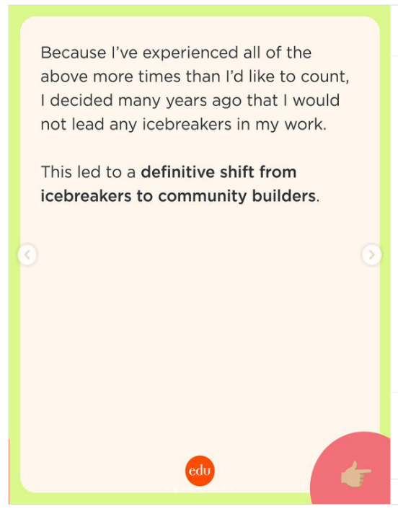 3.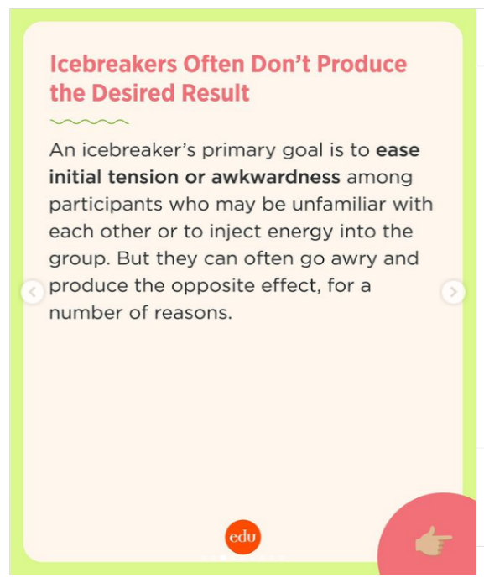

6. 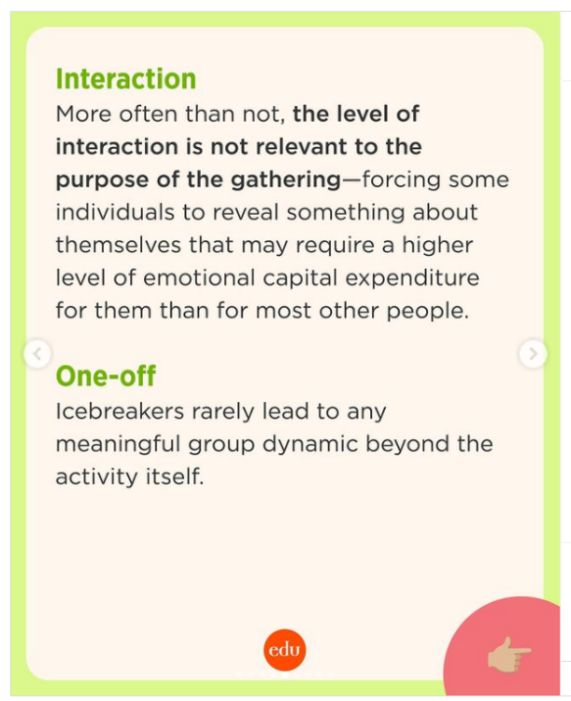

7.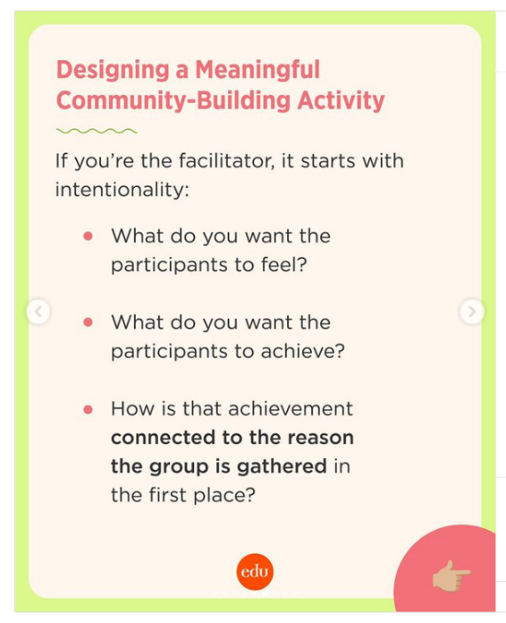 8.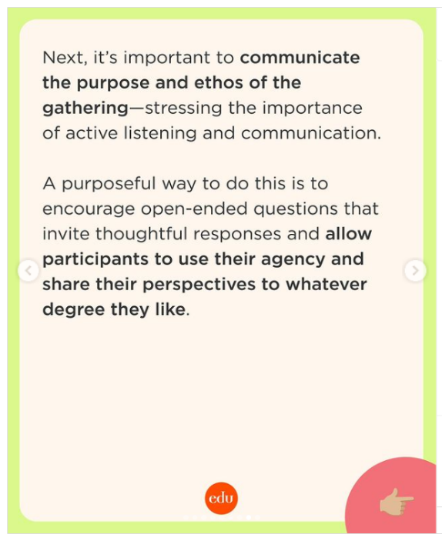 9.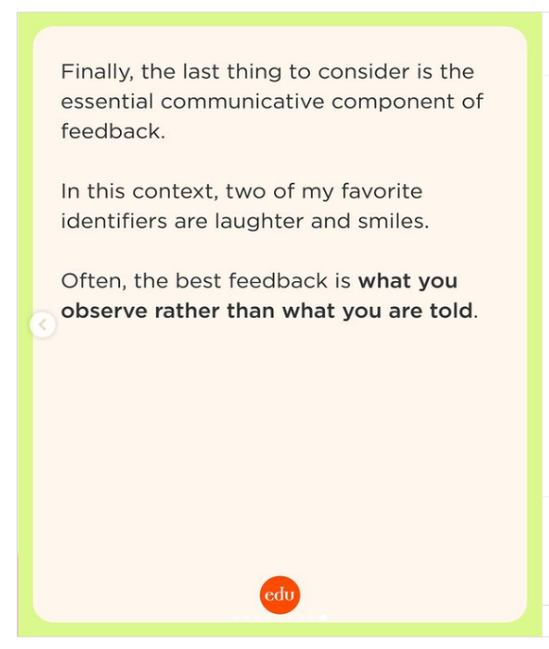

* 1. **27 Super-Smart, Teacher-Tested Closing Activities**

In the last few minutes of class, students’ minds are often focused on what awaits outside the classroom door—lunch, a pop quiz, a group presentation, unfinished homework, a chat with friends.

But when students “abruptly go onto the next class” without a moment to make sense of what they just learned, we miss a valuable opportunity to reinforce newly acquired learning. <https://www.edutopia.org/article/engaging-closure-activities/>

* 1. 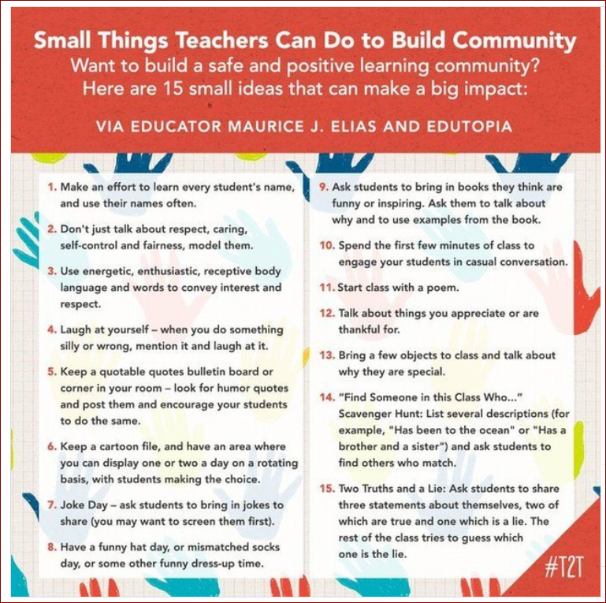

[Teacher2Teacher on Instagram: "Relationship-building doesn't have to be a heavy lift! ⁣ ⁣ Check out these simple strategies you can implement tomorrow, via @edutopia. Link in bio. #Teachergram"](https://gcc02.safelinks.protection.outlook.com/?url=https%3A%2F%2Fwww.instagram.com%2Fp%2FC-_MITuBWCe%2F%3Figsh%3DMWlwM25oNDEyc3cxcw%3D%3D&data=05%7C02%7Csarah.ferguson%40maine.gov%7Cb3ac473e951c4f145ee308dcc36c770b%7C413fa8ab207d4b629bcdea1a8f2f864e%7C0%7C0%7C638600117827893707%7CUnknown%7CTWFpbGZsb3d8eyJWIjoiMC4wLjAwMDAiLCJQIjoiV2luMzIiLCJBTiI6Ik1haWwiLCJXVCI6Mn0%3D%7C0%7C%7C%7C&sdata=Aw2KMUiIrfSWiaZSqCqJ8N8pP258DTsHqswy1I7Dd4w%3D&reserved=0)

* 1. **Postsecondary Education Options**

With the start of the new school year, high school seniors are looking toward their next big milestone: graduation.

Graduation signifies the transition from youth to adulthood, and the successful transition from high school to postsecondary education for all students requires early planning and collaborative efforts between educators, students and families.

In the seventh [**Expect, Engage, and Empower: Successful Transitions for All!**](https://gcc02.safelinks.protection.outlook.com/?url=http%3A%2F%2Ft1.info.ed.gov%2Fr%2F%3Fid%3Dh1207cf5%2C12aa676%2C12c9815&data=05%7C02%7Csarah.ferguson%40maine.gov%7C6df92d120fec41aa75b108dcc3a1cbad%7C413fa8ab207d4b629bcdea1a8f2f864e%7C0%7C0%7C638600346885846463%7CUnknown%7CTWFpbGZsb3d8eyJWIjoiMC4wLjAwMDAiLCJQIjoiV2luMzIiLCJBTiI6Ik1haWwiLCJXVCI6Mn0%3D%7C0%7C%7C%7C&sdata=%2FsACV0rfQOhQtKKJMnP%2BKJDXvEr0KbznboWfCjQVvsU%3D&reserved=0) blog post in the [**3E series**](https://gcc02.safelinks.protection.outlook.com/?url=http%3A%2F%2Ft1.info.ed.gov%2Fr%2F%3Fid%3Dh1207cf5%2C12aa676%2C12c9816&data=05%7C02%7Csarah.ferguson%40maine.gov%7C6df92d120fec41aa75b108dcc3a1cbad%7C413fa8ab207d4b629bcdea1a8f2f864e%7C0%7C0%7C638600346885852754%7CUnknown%7CTWFpbGZsb3d8eyJWIjoiMC4wLjAwMDAiLCJQIjoiV2luMzIiLCJBTiI6Ik1haWwiLCJXVCI6Mn0%3D%7C0%7C%7C%7C&sdata=0Pq6OIOLk9B75EqyZdfg%2Fe0WrUzopvwCOQC18pCxae4%3D&reserved=0), the Office of Special Education and Rehabilitative Services (OSERS) addresses postsecondary education options for students with disabilities. <https://sites.ed.gov/osers/2024/08/postsecondary-education-options/>

* 1. Graphical user interface, text, chat or text message

     Description automatically generated

1. **Link to SPPS Padlet:**

<https://padlet.com/gayeerskine/resources-for-sppss-6ip20lenh9odtu15>

**To get information about and to sign up for SPPS Director’s listserv:** [http://maillist.informe.org/mailman/listinfo/mesppsdir](https://gcc02.safelinks.protection.outlook.com/?url=http%3A%2F%2Fmaillist.informe.org%2Fmailman%2Flistinfo%2Fmesppsdir&data=05%7C02%7CGaye.Erskine%40maine.gov%7Cc056998b2364498201df08dc12bc877d%7C413fa8ab207d4b629bcdea1a8f2f864e%7C0%7C0%7C638405848154796819%7CUnknown%7CTWFpbGZsb3d8eyJWIjoiMC4wLjAwMDAiLCJQIjoiV2luMzIiLCJBTiI6Ik1haWwiLCJXVCI6Mn0%3D%7C3000%7C%7C%7C&sdata=QC7AuccYzB%2FkrUw9Z0IMqEN5OrLWPjejngFBllQTTU8%3D&reserved=0)

**ZOOM recording:** [https://mainestate.zoom.us/rec/share/voX9ozLHmeqinOC5I05d34SogtAbZbrCKiS5zsqWnivBPzqtDoNdWcMZ25Gde6kb.JXEiEo6LX_tJuSin](https://gcc02.safelinks.protection.outlook.com/?url=https%3A%2F%2Fmainestate.zoom.us%2Frec%2Fshare%2FvoX9ozLHmeqinOC5I05d34SogtAbZbrCKiS5zsqWnivBPzqtDoNdWcMZ25Gde6kb.JXEiEo6LX_tJuSin&data=05%7C02%7Csarah.ferguson%40maine.gov%7C67447238189e46ab9f0408dcd2778999%7C413fa8ab207d4b629bcdea1a8f2f864e%7C0%7C0%7C638616658056559590%7CUnknown%7CTWFpbGZsb3d8eyJWIjoiMC4wLjAwMDAiLCJQIjoiV2luMzIiLCJBTiI6Ik1haWwiLCJXVCI6Mn0%3D%7C0%7C%7C%7C&sdata=kSYuCEum8hB7KuQYS3EtwKMI4euvv%2F%2FIP3HBVRgey%2Fg%3D&reserved=0)

Passcode: *%^XP!?3