Special Service Director’s Meeting

January 18, 2024

Multilingual Learners with Disabilities

Jane Armstrong, ESOL State Specialist

**RESOURCES**

MDOE Website

* [Identifying and Serving Students Who are Multilingual Learners with Disabilities: Policy and Resource Guide](https://www.maine.gov/doe/learning/multilinguallearner/resources/MLdisabilities)
* Main page: [ESOL Newsletter & ESOL Listserv](https://www.maine.gov/doe/learning/multilinguallearner)

EMME (Educators for a Multilingual Maine) ESOL Teacher of the Year Nomination ([direct link](https://docs.google.com/forms/d/e/1FAIpQLSdZmRqnoB2CBv64AEYwZstRVd6lZWrXe3-Uiq_f1uOgRtkiUQ/viewform)) and EMME Conference March 8, 2024 [EMME (google.com)](https://sites.google.com/emmaine.org/emme/home?authuser=0)

* [ESOL Program Toolkit](https://www.maine.gov/doe/learning/multilinguallearner/resources/toolkit)
* [MDOE Data Dashboard](https://www.maine.gov/doe/Multilinguallearnerdatadashboard)

WestEd English Learners with Disabilities Network

* [2023-2024 Padlet](https://padlet.com/sderuvo1/wested-english-learners-with-disabilities-network-8mecmrxjiwvblvmt)

ELLevation Impact Series: Sara Kangas

* [Recordings](https://ellevationeducation.com/blog/impact-2023-session-recordings-and-resources) (includes slides, handouts, and resource list)

**QUESTIONS**

1. How are SPED and ESOL teams/teachers collaborating?

What systems & structures are in place to make this happen? What needs to be in place to make this happen?

1. Is there time for SPED and ESOL to learn together? What district and school structures can support this collaboration?
2. In your roles as Special Services directors, are you responsible for overseeing and/or directing ESOL programming in your district?

If yes, what do you need to support this responsibility? What training have you been provided to support this work?

**MDOE’s STRUCTURES of SUPPORT**

* 1-1 : Book an appointment found on my email signature
* Office Hours: 3:30-4:30 p.m. 1/22, 2/26, 3/25, 4/22, 5/20, 6/17 [**ZOOM LINK**](https://maine.us2.list-manage.com/track/click?u=a582edd6473e477ef6307c769&id=ca7cf3b529&e=0629e84e94) to register Open to anyone!
* MLAC: Multilingual Learner Advisory Council
* Focus Area Subcommittees: SLIFE Programming/Screener, MLs with Disabilities, Early Childhood, Seal of Biliteracy

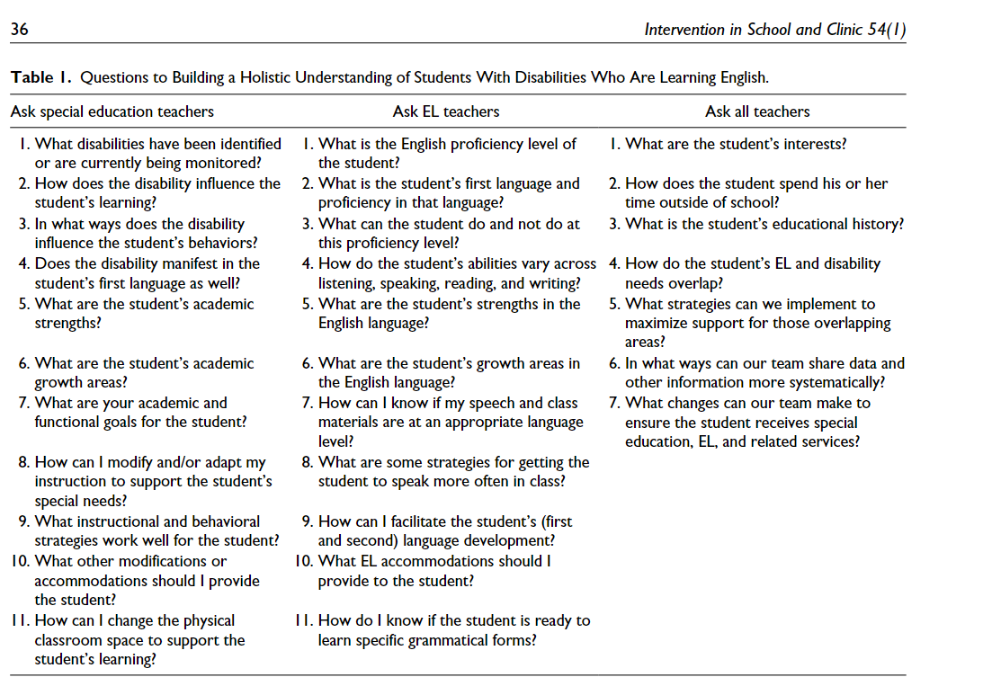

Table Source

[*“Why Working Apart Doesn’t Work at All: Special Education and English Learner Teacher Collaborations”*](https://padlet.com/sderuvo1/wested-english-learners-with-disabilities-network-8mecmrxjiwvblvmt/wish/2806301250)

Sara Kangas, PhD Lehigh University