Maine’s Children and Youth with Special Health Care Needs
Monthly Learning Series



Mission: Improve the health and quality of life for children with special health care needs and their families.

Education is Special
June 3, 2025, 3:30-4:30pm
Please Register Here

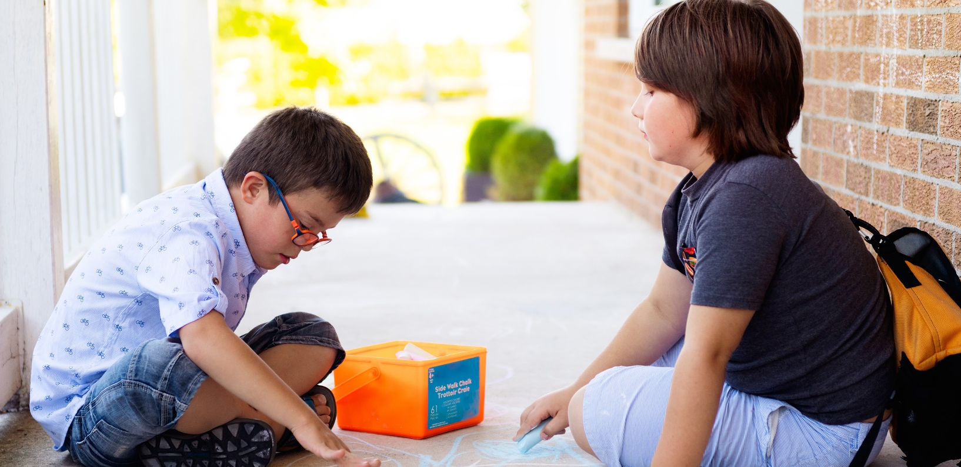
Join us for an insightful webinar on Education is Special. Special education in Maine can be a complex and confusing system to navigate. Many parents feel overwhelmed by the various rules, regulations and overall special education language. This training is a resource to help explain the process of special education and empower families to be active participants in their children’s education.
DHHS NON-DISCRIMINATION NOTICE
The Department of Health and Human Services complies with applicable Federal and State civil rights laws and does not discriminate on the basis of disability, race, color, sex, gender, sexual orientation, age, national origin, religious or political belief, ancestry, familial or marital status, genetic information, association, previous assertion of a claim or right, or whistleblower activity, in admission or access to, or the operation of its policies, services, or activities, or in hiring or employment practices.


Dylan Campbell - Dylan uses his lived experience navigating the many systems of care alongside his family, in support of his siblings with disabilities. Since 2017 Dylan has worked with Maine Parent Federation, the state’s Parent Training & Information as a Youth Coordinator and Parent Trainer. Since late 2021 Dylan has provided professional consultation to the Maine’s Department of Education Office of Special Services & Inclusive Education and acted as one of two co-chairs for Maine’s Executive Student Transition Committee. Dylan was also nationally recognized in 2022 as the recipient of the AMCHP Ryan Colburn Award for his work establishing youth-oriented programs and building connections with partners across the state of Maine and Northeast USA. Through commitment and collaboration, we can create an equitable and inclusive future for all.


Allison Wiest - Allison Wiest has been with Maine Parent Federation since 2017 acting as a Family Support Navigator to support families individually, and currently as a Parent Trainer providing information to families and professionals. Allison creates family-friendly materials and presents training to support and educate families of youth with disabilities and special health care needs on how to navigate the many systems of care. She also provides education to agencies and professionals that work with individuals with disabilities and collaborates with school systems to bring education and resources to students and their families. Some of the trainings topics include, Education is Special, Transition Planning, Supported Decision Making and Self Advocacy for youth.
Allison has partnered with the University of Maine’s Center for Community Inclusion & Disability Studies to present trainings on Family-Centered Transition Planning and Person Centered Planning to bring better future outcomes for youth in our state. Currently, she is partnering with Maine Family Planning to bring sexual health education to youth and their families. In addition, she speaks with UNE medical students and UMF special education students and has sat on Parent Panels to increase awareness and provide parent perspective to college students as they prepare for their careers.
She serves on the University of Maine Center for Inclusion and Disability Studies Community Advisory Committee as a parent of a child with a disability. She is a member of the Maine State Rehabilitation Council for the Division of Vocational Rehabilitation representing Maine Parent Federation, the states parent training and information center. Allison is passionate about educating and empowering individuals and families to increase independence and better outcomes for the future.
Personally, she is the mom of a thirteen year old boy with Autism and advocates daily to ensure his needs are met. She has created inclusive sport opportunities including Buddy Baseball and Unified Soccer in her community for youth with different abilities and continues to seek and provide more opportunities.
The Children and Youth with Special Health Care Needs, Health Care Coordinator provides a unique resource for families, providers, and communities. The goal is to assist families and providers in finding services that will help the child or youth acquire optimal health, development, well-being, and the best quality of life.
To learn more please visit us at:
https://www.maine.gov/dhhs/mecdc/population-health/mch/cshn/
Email: MCH.CDC@maine.gov
Phone: 207-287-5357
TTY users call Maine relay 711




