Maine’s Children and Youth with Special Health Care Needs
Monthly Learning Series



Mission: Improve the health and quality of life for children with special health care needs and their families.

Childhood Lead Poisoning and Prevention
December 3, 2024, 3:30-4:30pm
Please Register Here

Join us for an insightful webinar on the effects of lead on children; children who are at risk for lead exposure and ways to prevent lead exposure.
At the end of this presentation, participants will:
- Be able to identify children at risk for exposure to lead.
- Be able to understand the importance of testing children for lead.
- Be able to identify health effects of lead in the blood.



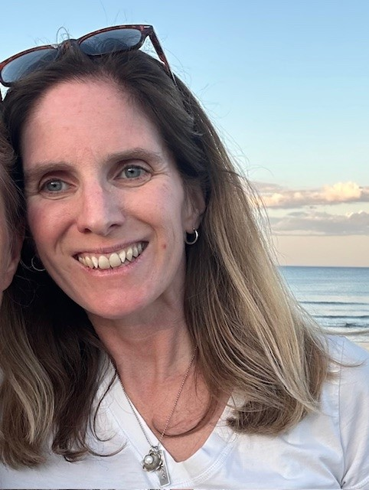

My name is Maggie Bordeau. I am the public health physician
for the ME CDC childhood Lead poisoning Prevention Program (CLPPP) and have been a pediatrician for 20 years. I went to medical school at UNE college of Osteopathic medicine and
did my residency at CT Children’s hospital in Hartford CT. I
received my MPH from UCONN while I was a resident. I live
in Biddeford with my husband and 2 children.

The Children and Youth with Special Health Care Needs, Health Care Coordinator provides a unique resource for families, providers, and communities. The goal is to assist families and providers in finding services that will help the child or youth acquire optimal health, development, well-being, and the best quality of life.
To learn more please visit us at:
https://www.maine.gov/dhhs/mecdc/population-health/mch/cshn/
Email: MCH.CDC@maine.gov
Phone: 207-287-5357
TTY users call Maine relay 711



DHHS NON-DISCRIMINATION NOTICE
The Department of Health and Human Services complies with applicable Federal and State civil rights laws and does not discriminate on the basis of disability, race, color, sex, gender, sexual orientation, age, national origin, religious or political belief, ancestry, familial or marital status, genetic information, association, previous assertion of a claim or right, or whistleblower activity, in admission or access to, or the operation of its policies, services, or activities, or in hiring or employment practices.

