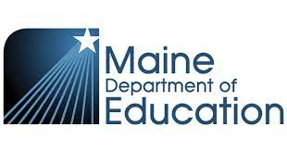
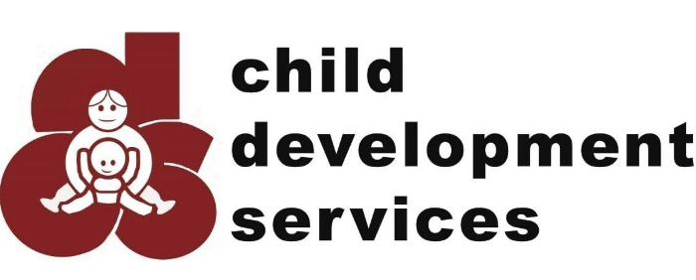



Partners in Progress
Thursday October 5th, 2023 6pm-8pm
Maine Medical Center - Dana Center Auditorium
A special event for patients, families, caretakers, school nurses, school counselors and others whose lives have been affected by congenital heart disease.
Come learn about the new CHD programs offered at MaineHealth from infant to adults.
If you cannot attend in person and would like a virtual link sent to you please email
CongenitalHeart_Happenings@mainehealth.org

Congenital Heart Symposium

